Dataset is massive. We are unable to upload into the moodle website. Below are the instructions to download the dataset.

1. Click on the [Climate change data set](https://www.kaggle.com/berkeleyearth/climate-change-earth-surface-temperature-data) or go to <https://www.kaggle.com/berkeleyearth/climate-change-earth-surface-temperature-data>.
2. Click on Download tab on the kaggle website.
3. Automatically data will be downloaded into the system.

Attached screenshot for your reference.

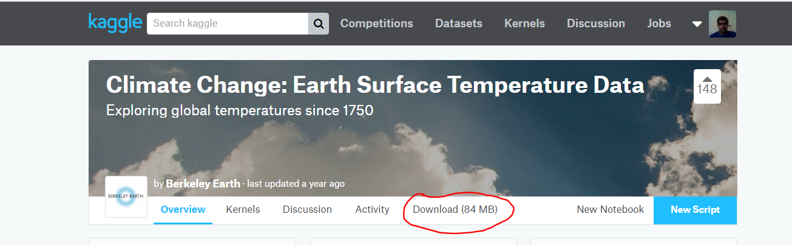

We have used only “GlobalTemperatures.csv “, “GlobalLandTemperaturesByCity.csv”, “GlobalLandTemperaturesByCountry.csv”, “GlobalLandTemperaturesByMajorCity.csv” file for our analysis.

As moodle is allowing us to upload three files, we are attaching R script to this document as an object.

